HEALTH & DAMAGE

Create a Health Component

Create a health component class.

- Add a new folder called Components in the Blueprints folder.

- Open BP_CharacterBase and Add a New Blueprint Script Component from the Components panel, and name the new blueprint class BP_HealthComp.

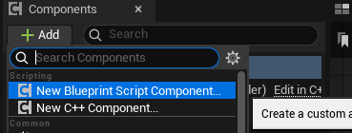

Set up a few variables.

- Open BP_HealthComp and add two variables of the type float.

- Name the first one MaxHealth and the second one CurrentHealth.

- Set both of their values to 100.

Subscribe to the damage system.

- In the Event Graph, create a Get Owner node.

- Drag out from the Return Value of the Get Owner node, search for Bind Event to On Take Any Damage, and press Enter to create a Bind Event to On Take Any Damage node.

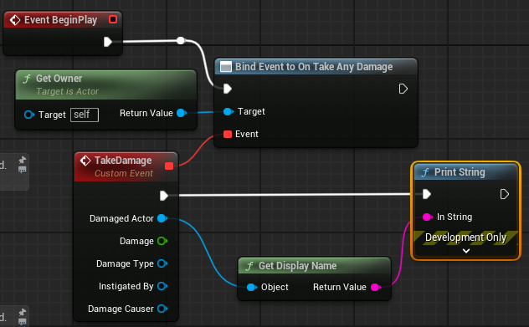
- There is an Event input pin of this new node, drag out from it, search for add custom event, and hit Enter to create a custom event.

- Name the new custom event TakeDamage. This new event has some input added already. By binding it to the On Take Any Damage of the owner, it gets called whenever the owner takes damage.

- Call the Bind Event to On Take Any Damage from the Event BeginPlay. In the TakeDamage custom event, we can try to print out the name of the damaged actor for now.

Copy BP here

Test the binding.

- Open BP_CharacterBase. Confirm it has the BP_HealthComp in the Components panel.

- Delete the Event AnyDamage event we created in the previous lesson. We don’t need it anymore because the BP_HealthComp is now binding with it.

- Play the game and shoot the BP_CharacterBase in the level, and we can see the BP_CharacterBase got printed.

Calculate damage.

- On the health component, add a new event called CalculateDamage. Implement it and call it with TakeDamage as shown.

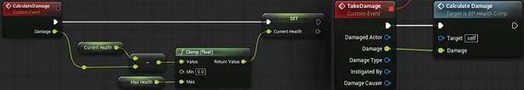

Copy CalculateDamage BP here

Add a health blueprint interface.

- We want to inform the owner when it is hurt, dead, or it needs to update its UI. But the problem here is we don’t know who the owner is, and we want it to work for anyone. Let’s use a new concept called blueprint interface to tackle this issue.

- Right click in the empty place in the Content Browser and select Blueprints → Blueprint Interface.

- Rename the new interface BPI_HealthComp and double click to open it.

- Go to the My Blueprint panel, and rename the NewFunction_0 to HealthCompNotify_TookDamage.

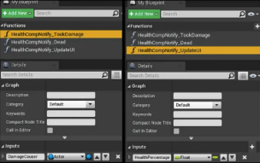
- Go to the Inputs section of the Details panel and add an Actor object reference input called DamageCauser.

- Add two new functions by pressing the “+” sign twice. Name one of them HealthCompNotify_Dead and the other one HealthCompNotify_UpdateUI.

- With the HealthCompNotify_UpdateUI selected, go to the Details panel and add a new float input called HealthPercentage.

Add interface call.

- Go back to BP_HealthComp, create a RequestUpdateUI and a CheckDeath custom event, and implement them as shown.

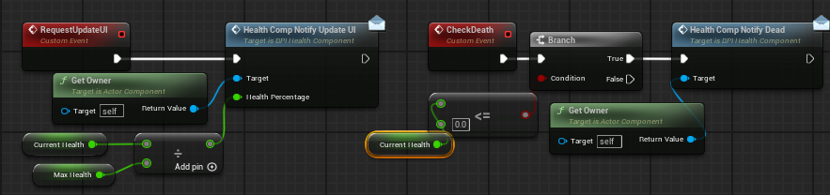

Copy BP here

Call RequestUpdateUI and CheckDeath in TakeDamage.

- At the end of the TakeDamage function, add more stuff as shown.

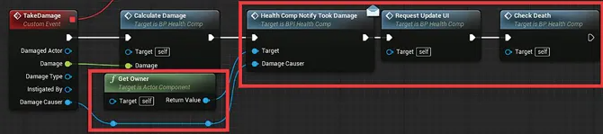

Copy BP here

Add BPI_HealthComp interface to BP_CharacterBase.

- Open BP_CharacterBase, and click on the Class Settings in the toolbar.

- Click on the Add button in the Interfaces section in the Details panel.

- Search and add BPI_HealthComp.

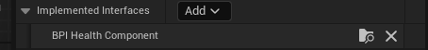

Make BP_CharacterBase receive interface calls.

- After adding the interface, a new section called Interfaces was added in the My Blueprint panel.

- Open it and you can see all the functions we created in BPI_HealthComp.

- Right click on each one of them, and select the implement event function. Three new events were created; implement them as shown.

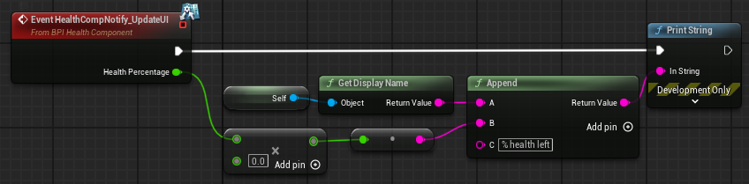

Copy BP here

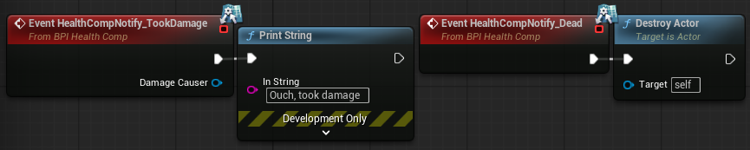

Play the game and shoot the BP_CharacterBase we placed in the scene, and we can see all the correct information printed, keep shooting, and we can eventually kill that BP_CharacterBase.

Fix the Camera
Make the body look up and down with the camera.

- Open Character_FPS and select the PlayerEye object.

- In the Details panel, search for Use Pawn Control Rotation and check the box.

- In the Event Graph, drag from the Parent: Begin Play node and create an Attach Component to Component: Mesh node.

- Drag the Player Eye mesh into the Parent input pin.

- Set all of the Rules to Keep World.

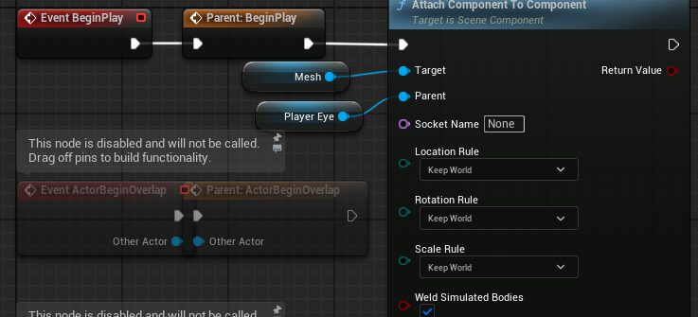

Copy BP here

Now the camera functions work much better for a FPS, you can look up, and you won’t see your own body.

- Switch the weapon in BP_CharacterBase in the Acquire New Weapon function called in Event BeginPlay to BP_GrenadeLauncher.

- Try to shoot our own feet (shoot downward), and we should be able to kill ourselves with the grenade. If we want anything to take damage, we simply add BP_HealthComp and BPI_HealthComp, and implement these functions.

- More importantly, if we want the whole health system to work differently, we modify BP_HealthComp, and everyone gets the new update.

Character Hit and Death

Create a hit react animation.

- Download a “Getting Hit” animation from Mixamo, or create a similar additive animation just like how we did with the weapon switching.

- Here’s a link to Importing Characters from Mixamo as a reminder.
  - Drag FBX animation into Animations folder
  - Check ‘Import Only Animations’
  - Select SK_Player for the skeleton

- Call it AS_Hit, and make an animation montage out of it which can be called ASM_Hit.
  - Right click it > Create > Create Animation Montage

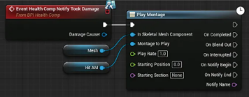
Test the hit animation montage.

- Go back to BP_CharacterBase, and change the implementation of Event HealthCompNotify_TookDamage to as shown on the right.

Copy BP here

Create a dummy AI.

- Create a child blueprint class of BP_CharacterBase and name it BP_DummyAI.

- Open it and find the Event Tick. This Tick function is called every time the game updates and calls Attack with it, which makes this dummy AI shoot forward as fast as possible.

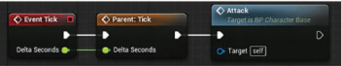

- Replace the BP_CharacterBase in the level to BP_Dummy_AI, and rotate it to make it face the player.

- Play the game and face that BP_Dummy_AI, and she starts to shoot you as fast as possible after getting the gun. She even reloads, which is pretty cool.

But there is one thing strange here: if you hit her a few times, she stops shooting. You would think that she is out of ammo, but that can’t be the case because you have the same amount of ammo, and you know it takes one round of reloading to run out of ammo.

It's because of the hit montage. Any new montage fired overrides the previous one in the same group, and all of our montages use the default group. The hit animation montage overrides the shoot montage, which makes the shoot montage stop prematurely and that causes the ANS_WeaponAttack never reach to the end notify to change the WeaponState back to idle. We can fix this issue by assigning the hit montage to a different group and slot .
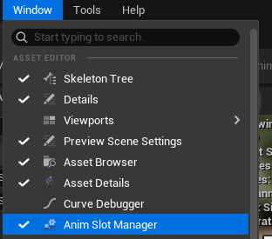
Create and assign a new group and slot to the hit animation montage.

- Open ASM_Hit, and go to the Anim Slot Manager on the lower right corner of the window (it might be shuffled behind the Asset Browser).
  - If you don’t see it, click on Window at the very top toolbar, and select Anim Slot Manager.

- Click on the Add Group button and type in Reaction as the new group name. A new group called Reaction gets added to the Slot Name list.

- With (Group) Reaction selected, click the Add Slot button to add a new slot to it and type in ReactionHit as the slot name.

- Finally, go to the timeline, under the Montage section, click the tiny drop-down triangle button of the DefaultGroup.DefaultSlot, and select Slot Name → Reaction.Hit.

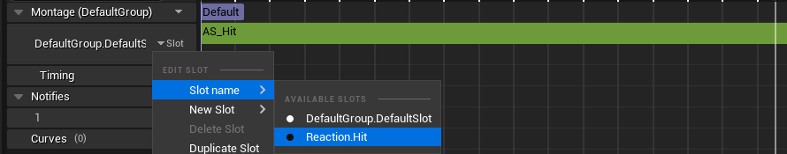

Add the slot to the animation blueprint.

- Go to the AnimGraph of the animation blueprint.

- Delete the Slot ‘Hit’ node.

- Add a new Slot ‘DefaultSlot’ and insert it between the old Slot ‘DefaultSlot’ and the Out Pose node.

- With this new slot selected, go to the Details panel and set the Slot Name to Reaction.Hit.

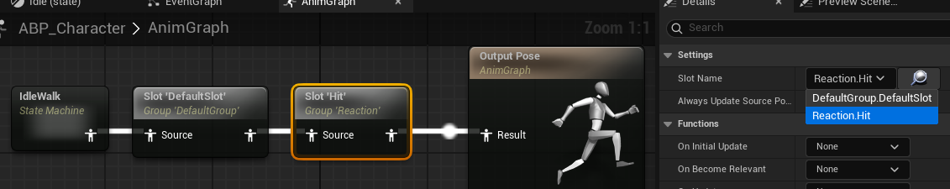

Play the game again, and you can see that the hit animation montage does not override the other animations anymore. Animation montages that have different groups do not cancel each other.

Create the death animation montage.

- Find the Dealth_From_The_Back animation, create an animation montage from it, and name them with our conventions (AS_DeathFromBack, ASM_DeathFromBack).

- Open the new ASM_DeathFromBack in the Asset Details panel and check off the Enable Auto Blend Out under the Blend Options section.

- We don’t want it to blend back; that would make the character stand up again.

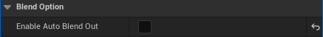

Create a StartDeathSequence custom event.

- Go back to BP_CharacterBase and create a custom event called StartDeathSequence.

- Implement the event as shown below. And call it after Event HealthCompNotify_Dead.

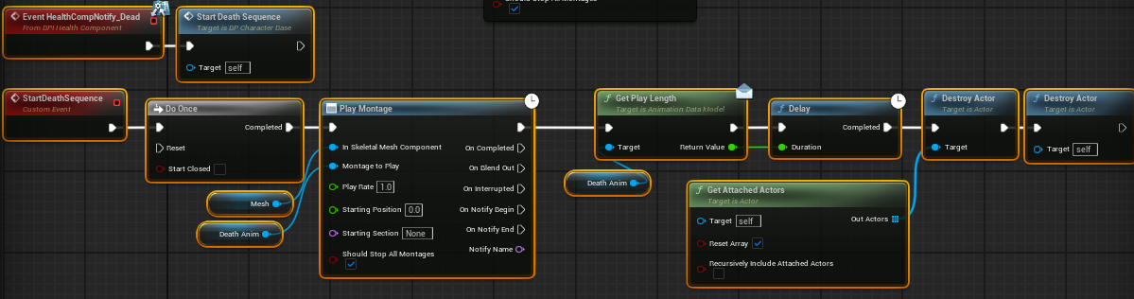

Copy BP Here

Play the game again and keep shooting the dummy character. However, when the character is dead, surprisingly, nothing happens, and the character will keep shooting and finally disappears. Well, it is because the character never stops attacking. And the attack animation montage again cancels the death animation montage.

Create a CanOperateWeapon function.

- Add a new function to BP_CharacterBase, and name it CanOperateWeapon. Implement it as shown below and insert it with a branch at the beginning of the Attack and Reload event.

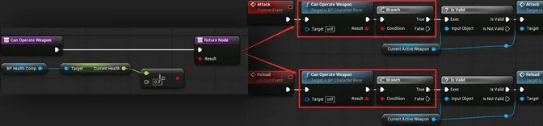

Copy CanOperateWeapon function here

Think about what we have done so far, and there is one thing worth modifying. The Do once does its job nicely to prevent the death sequence from happening again. But should it be in BP_CharacterBase or should it be in the BP_HealthComp? Well, if you want this dead only once behavior to happen to all your objects in the game, then putting it in BP_HealthComp makes more sense. Otherwise, you have to add Do Once to all the death functions.

Let’s remove the Do Once node from StartDeathSequence and add it to CheckDeath as shown.

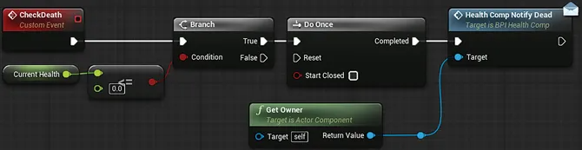

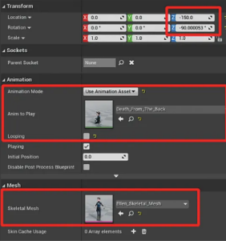
Player character death pawn.

- For the player, we want to switch to a top-down view and see the full body of the character playing the death animation as well.

- Create a new BP class derived from Pawn and name it BP_PlayerDeathPawn.

- Add a Skeletal Mesh component to it. In the viewport, rotate the mesh to make it face the X-axis and move it down 150 units.

- Go to the Details panel and set the Skeletal Mesh to your character, in my case SKM_Ogre.

- Under the Animation section, change the Animation Mode to Use Animation Asset, and set the Animation to Play to AS_DeathFromBack.

- Check off the Looping under the Animation to Play as well.

Set up a camera.

- Select the DefaultSceneRoot in the Components panel.

- Add a Spring Arm component and a Camera component.

- Make sure that the camera is parented under the spring arm.

- Rotate the spring arm up to −60 degrees on the Y axis, and move it up 50 units.

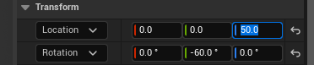

Set up a player controller.

- Create a new class derived from PlayerController and name it BP_CharacterFPS_PlayerController.

- Click on the Class Defaults button in the toolbar, go to the Details panel, and check off the Auto Manage Active Camera Target option.

- In the Event Graph, right click, search, and create an Event On Possess and an Event On UnPossess.

- These two events are called when this player controller possesses and unpossesses a pawn. Implement them as shown.

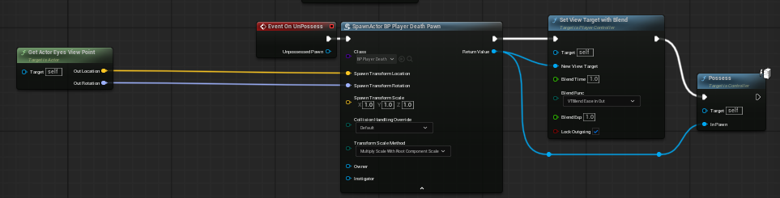

Copy BP here

Create the Get Actor Eyes Viewpoint node by right-clicking and searching, and you’ll have to split the Spawn Transform input pin on the Spawn Actor node by right-clicking on it.

Make sure to set the Blend Time to 1, Blend Func to VTBlend Ease in Out, and the Blend Exp to 1 to have the camera blend to the target with ease in ease out effect.

Override StartDeathSequence and set the PlayerControllerClass in the game mode.

- Open BP_CharacterFPS, and in the Event Graph, override (override button next to Functions tab) the StartDeathSequence just to destroy all attached actors and the destroy self. As shown below.

- Go to Blueprints/GameModes/, open GM_CharacterFPS, and set the Player Controller Class Under the Classes section to BP_CharacterFPS_PlayerController.

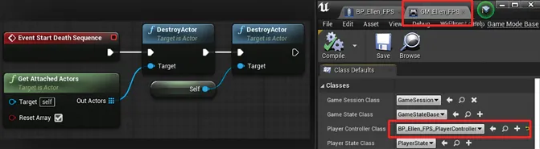

Copy BP here

Play the game again and let the dummy AI shoot you.

- To make it easier, you may have to go to BP_CharacterBase, BeginPlay node, and change the AcquireNewWeapon dropdown to the Gun.
- You may also have to open your BP_Gun, and change the Damage variable to something like 50 so you die in 2 shots.

When you die, you will see yourself playing the death animation and smoothly transitioning to a third-person view. The game would be too hard if there is no way to regenerate health; let’s quickly create a health regeneration actor.

Health Regen

Create BP_HealthRegen and set up its visuals.

- Go to the Blueprints folder, and create a new folder called HealthRegen.

- Inside of HealthRegen, create a new blueprint class derived from BP_Triggerable. Name the new class BP_HealthRegen.

- Open BP_HealthRegen.

- Add two Cube Components to it, scale, and rotate them to create a 3D cross figure.

- Drag one of the cubes on to the other one to parent it to the other one, and rename the parent cube Cross.

- Set the Collision Presets to NoCollision on both cubes.

- Assign the cubes a material, the default HueShift_Inst for example for a vibrant green.

- The image below shows the final visual of the setup.

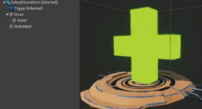

Make the Cross rotate.

- Go to Event Graph, find the Event Tick, and add the code shown.

- Make sure to set the multiply input value to something like 200.

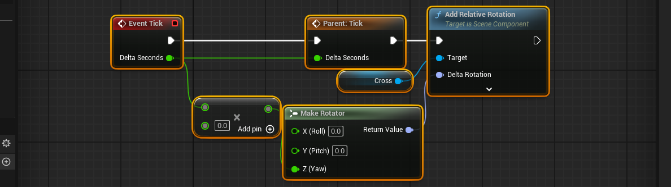

Copy BP here

Add regeneration functionality to the BP_HealthComp.

- Open BP_HealthComp, add a new function called RegenerateHealth, and implement it as shown.

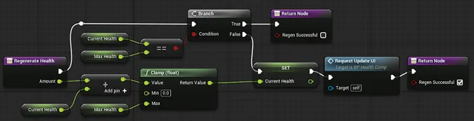

Copy BP here

Implement a Consumed custom event.

- Implement a new custom event called Consumed in BP_HealthRegen and implement it as shown.

- I used this free Zap niagara effect from the Fab store which looks pretty good. This is what I used in the System Template input pin. Search for it from the Fab store in your editor to add it to your project faster.

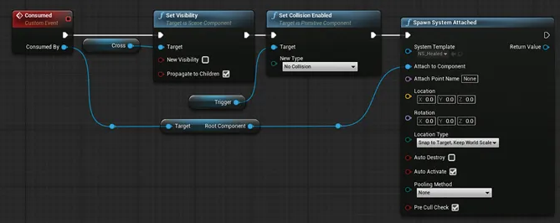

Copy BP here

Override Overlapped event.

- Override the Overlapped event as shown.

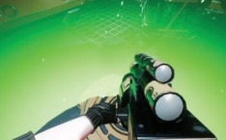
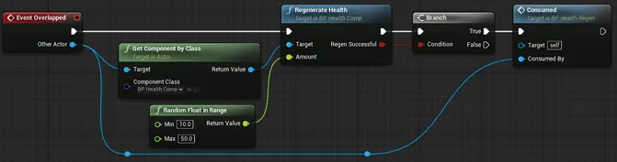

Copy BP here

- Go to the BP_HealthComp and set your max and current health to something higher like 500.

Play the game again and take some damage. You should now be able to consume the BP_HealthRegen.

Make it go back after 10 seconds.

- At the end of our Consumed event, add the code shown.

- Don’t forget to change the Duration value to 10.

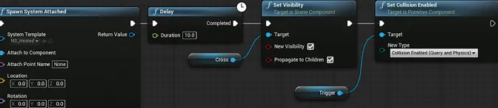

Copy the end of the Consumed event here

Give the game another go, and now you can consume it when you take damage, it will go back again after 10 seconds.

Fix an error

- Place an IsValid node after the Get Component by Class node in the Event Overlapped event to prevent errors from appearing during runtime

